**File storage**

Microsoft Azure offers several options for storing data in the cloud, including Azure Files, Azure Blob Storage, and Azure Archive Storage. Azure Files is a managed file share solution that allows users to share data between containers using NFS or SMB file shares. Azure Files can span up to 100 TiB in local and zone redundant storage accounts, but only up to 5 TiB in geo- and geo-zone redundant storage accounts. Azure provides a File Storage service that enables you to create file shares in the cloud and easily share files across multiple virtual machines (VMs).

Modern applications use Microsoft Azure Storage as their data storage option because it offers massively scalable, reliable, and always-on cloud storage.



File Storage, as opposed to Azure Blob Storage, enables the cloud sharing of fully managed files that should be accessed via the industry standard SMB protocol. The type of data is the primary distinction between Blob Storage and File Storage. Only structured data is allowed in Azure File Storage.

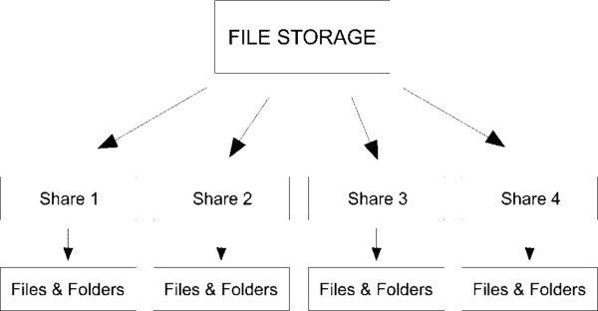

File Storage is accessible and universal. It allows you to mount file share to any compatible operating system; Linux and macOS, and NFS for Linux and macOS. The REST API also allows programmatic access through the FILEREST API via HTTP & HTTPS.

The most notable things about Azure File Storage are that you can access the file anywhere in the world. Using the URL of the file must include the Share Access Signature (SAS). SAS helps to create specific access for a particular time.

**Azure File Storage Use Cases:**

Deployment and testing: It can be used to build a central repository for code and be used for both.

Monitoring and Analytics: You can centralize measurements and log files for metering and administering the analytics tool using the monitoring and analytics feature of File Storage.

Application Share: For application data and configuration files, Application Share - File Storage serves as a centralized file share. The fact that it only enables SMB access is one drawback.

File servers: Using Azure storage sync, you have the option to replicate data locally, boost performance, and implement distributed caching.

Lift and shift migration: By maintaining the present protocols, lift and shift migration enables you to migrate either data and application or both "as-is".

**Features of Azure File Storage**

- File Shares:

You can build file shares in Azure File Storage that function like network file shares, allowing you to store and share files online. It is practical in situations where shared access to files is necessary because file shares are organized within a storage account and may be accessed by numerous VMs simultaneously.

- Protocols:

Various operating systems can be used with Azure File Storage because it supports both the SMB and NFS protocols. For Linux-based virtual machines, you can mount Azure file shares as file systems, and you can mount them as network drives for Windows-based virtual machines using SMB. You may incorporate Azure File Storage into your current infrastructure without any issues thanks to this flexibility.

- Storage Accounts:

The Azure Storage service, which comprises of storage accounts, includes Azure File Storage. Azure storage resources, such as file sharing, are organized at the top level in storage accounts. You link new file shares to particular storage accounts when creating them. Within the context of the storage account, you can handle file-sharing access control, monitoring, and billing.

- Performance and Scalability:

Azure File Storage offers automatic scalability to address increasing data volumes and is built to handle large-scale storage requirements. Azure File Storage automatically changes the underlying infrastructure to accommodate demand as your storage requirements grow. For applications that need quick and dependable access to file data, it provides high-performance access to files, enabling effective data transfer and retrieval.

- Redundancy and Durability:

Azure Storage offers options for redundancy and durability to guarantee the accessibility and accuracy of your data. Locally redundant storage (LRS), which replicates data inside a single data center, is the default setting for creating file shares. This offers excellent durability and safeguards against hardware breakdowns. In order to increase data resilience, you can additionally select geo-redundant storage (GRS) or zone-redundant storage (ZRS), which both provide redundancy across availability zones.

- Access control and security:

Azure File Storage provides strong security measures to safeguard your data. Several methods, such as Azure AD integration, which provides authentication and authorization using Azure AD credentials, can be used to restrict access to file shares. In order to offer time-limited access to file shares, you can also create Shared Access Signatures (SAS). Access keys offer a different type of authentication. In order to ensure that your data is secure while being stored in Azure, Azure File Storage also provides encryption at rest.

- Integration:

You may use Azure File Storage's features in a variety of contexts thanks to its seamless integration with other Azure services. As an illustration, you can directly mount Azure file shares in Azure virtual machines to provide shared storage for numerous VMs. Hybrid cloud deployments are made possible by Azure File Sync, which lets you synchronize on-premises file servers with Azure File shares. Azure Backup offers alternatives for data protection and recovery and supports file-level backups from Azure File Storage.

- Cost:

Several factors, including the volume of data saved, the number of operations (such as reads and writes) made, and the quantity of data transferred into and out of file shares, affect the cost of using Azure File Storage. The price model takes into account the region where the storage account is located as well as the redundancy option selected (LRS, ZRS, or GRS). To help calculate and minimize the costs related to using Azure File Storage, the company offers cost estimators and price information.

By giving you a deeper understanding of Azure File Storage and its features, these thorough explanations enable you to make the most of its capabilities in your cloud-based file storage and sharing situations.